# CMIS Connector for OpenText Capture Center

## Content Management Interface Standard (CMIS) describes an interface that should provide inter-operability between a CMS and a client application. With the CMIS extension OCC should be able to export data to various systems.

## The CMIS Export Extension for OCC is in alpha state. Most functions have successfully been tested against several target systems. Some restrictions apply for some systems.

|  |  |
| --- | --- |
| System | Status |
| InMemory CMIS as provided at chemistry.apache.org, version 0.9.0-beta-1 0.9.0-beta-1 | Fully functional, no restrictions |
| OpenText Archive Center | Minor versions are not supported by Archive Center, otherwise fully functional |
| OpenText Domea | Versioning does not work |
| Alfredo CMS | Fully functional, no restrictions |
| SharePoint 2013 | Types cannot be loaded -> not operational at this point in time |
| OpenText Documentum | Initial test show its fully working |

## The CMIS connector provides basic capabilities: Uploading of documents and setting the properties for that document type. Relations are not supported and therefore table fields cannot be uploaded with the CMIS connector. Secondary types are not supported either.

## The connector uses the PortCMIS client library from the Apache Chemistry project.

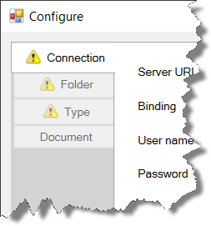The connector provides four tabs, one for defining the connection parameters, one to select the folder and deals with file name settings and collision handling, one that allows to specify the properties that should show up as index fields in OCC and one to define the document name. Each tab shows a warning symbol as long as that tab is not fully configured.

## Connection Tab

Use the connection tab to provide login parameters and to select the repository to work with.

**Server URL / Binding:**  
Enter the complete URL to access the server. Please note that the URL must correspond to the selected binding. Select the binding that you want to use. AtomPub is the preferred binding and is recommended. Web services will only work when HTTPS is chosen and will require a valid certificate on the server.

**User name / Password:**  
The user will be used to connect to the server during configuration as well as during document  
upload. Use a technical user.

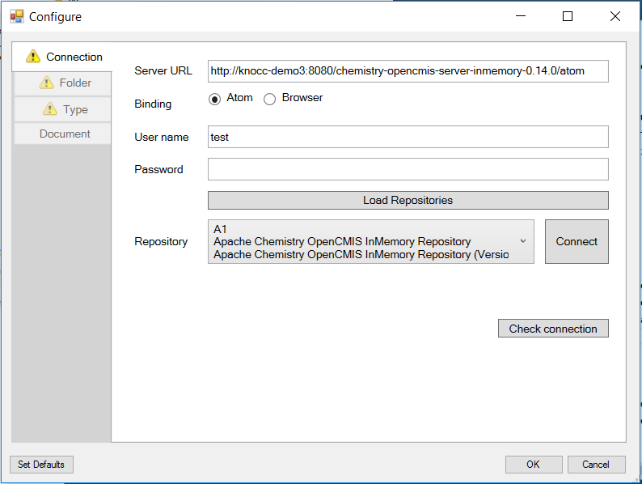

**Load repositories:**  
When hitting the "Load repositories" button the server will be connected, user credential will be verified and the list of available repositories will be loaded. Once loaded you can select one of the repositories and connect to that repository by pressing "Connect". Once done the other two tabs will become available.

**Connect:**  
Connects to the selected repository and switches to the Folder tab.

**Check connection:**  
The Check connection button tries to connect to the specified system and returns a status. It executes three operations. Please note that the first of the three action may fail while the other two succeed. The first is a Ping operation and some systems do not respond to the ping call.

## Folder Tab

Use the folder tab to specify the folder you want to store the file and other specifics of the document upload. You can specify a root folder; the final folder can be determined dynamically based on the data extracted from the document.

**Root folder:**  
Select the root folder by navigation through the folder tree. The "Root folder" field displays the selected folder and cannot be edited.

**Subfolder from field:**  
For dynamic subfolder determination you have to specify a field name. That field name is created as part of the meta data schema for OCC and must be set during the extraction process. The name can contain '/' characters to create sub-sub folders. Example: The root folder is "/Home" and "Subfolder from field" is set and contains "sub1/sub2/sub3". When the document reaches the export stage, the document will be stored in "/Home/ub1/sub2/sub3".

**Subfolder type:**  
The value of this field is taken as a CMIS folder type that is used when creating dynamic subfolders. If not activated "cmis:folder" is used.

**Subfolder type field:**If this option is enabled the subfolder type is determined dynamically from the content of the specified field. Thus the dynamic folder that is created may be of different types depending on the document content. If both option, "Subfolder type" and "Subfolder type field" are active the latter has preference. Only then the specified field is empty the value for the sub folder type is chosen from "Subfolder type".

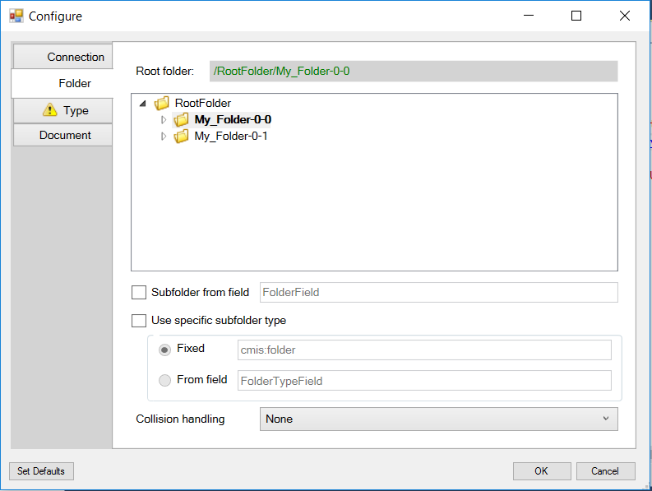

**Collision handling:**  
This selection allows you to specify what should happen if a document of the same name already exists in the given folder. The possible options are:

* None: In this case nothing is done. Normally the document export will fail unless the repository allows the co-existence of multiple documents with the same name.
* Replace: When this option is chosen, the existing file will be deleted before the new document is uploaded.
* AddVersion: When this option is chosen a new version of the document is created. This will only work when the original document was created accordingly. A radio button lets you chose whether you want to create major or minor versions.
* AddNumber: This option will change the document name by adding a consecutive number. The resulting document will be named "Document_0001.pdf" or "Document_0002.pdf" and so on. The number of digits used can be specified by the parameter "Number of digits". When you chose this option you should make sure that only one cluster node in the OCC system is assigned to this export, otherwise there's a small chance of parallel cluster nodes creating files simultaneously and then failing.
* AddBlurb: This option will add a random 12-character string to the document name.

## Types Tab

This tab lets you specify the document type and by that the properties that make up OCC's Meta data schema.

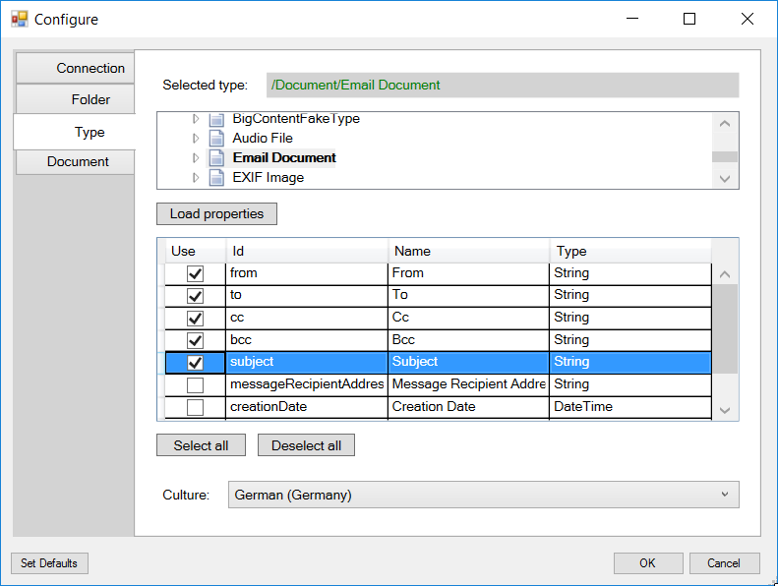

**Selected type:**  
Select the document type by navigating the type tree. The field "Selected type" shows the selected type and is read only.

**Load properties:**  
Once a type is selected you can press *Load properties* to load the properties of this type. When you have selected a document type all available properties for this document type are displayed. You can choose the one that you want to be set by OCC.

**Culture:**Select the culture that should be used when converting OCC strings to CMIS property values.

## Document Tab

On the Document tab, you specify the format of the output filenames.

By default, the filename comprises the batch ID and the document number within the batch. To modify the filename specification:

* Remove placeholder strings as needed.
* Enter characters in the text box as needed. These characters will appear unmodified in all filenames.
* Click the respective buttons to add placeholders to the specification.
* To add the value of an entity property, click the property in the entity property list, and then click Add.

An example string always shows a filename according to the current specification.

To use the input filename click *Create document name from input filename*.

